**TEST SUMMARY**

The document explains the various activities performed as part of the Testing of Facegenie website (https://facegenie-ams-school.web.app/). This website provides different functionalities for users to Manage Student, Manage Licenses etc. In the Manage Student page users can add,read,delete student details. In the Manage License page users can add employee details. Test Metrix are shown below which include both manual and automated testing results.

| **Test Summary** | | |
| --- | --- | --- |
| **ASSESSMENT** | **Total number of Test Cases** | **Comments** |
| Test cases Automated | 7 |  |
| Test cases Executed | 15 |  |
| Test cases Passed | 10 |  |
| Test cases failed | 5 | Critical Bugs are there |

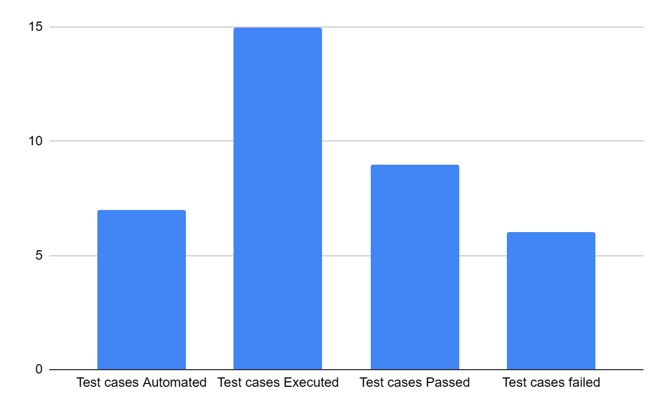

**RECOMMENDATIONS**

* It could be better to include the Forgot Password link on the login page.
* It could be better to show the field required message on any missing field.
* It would be better to show an error message on any error data field.
* It could be better if the error message should be in a noticeable format. Otherwise the user can’t catch it correctly.

**CONCLUSION**

Critical bugs are still open, also some high,medium and low priority bugs are open. So forwarding to the development team to fix all the bugs. After fixing these bugs will be moving to retest and Regression Test.